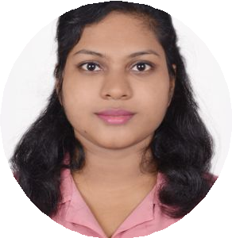REBATI SAHU

**S o f t w a r e E n g i n e e r**

# SKILLS CONTACT ME

Html/css Javascript

Web Development Debugging

Node JS Communication

 8457061634

[rebatibalasahu123@gmail.com](mailto:rebatibalasahu123@gmail.com) Bhubaneswar

 [https://www.linkedin.com/in/reba ti-bala-sahu-726247163?lipi=urn% 3Ali%3Apage%3Ad_flagship3_pro file_view_base_contact_details%3 BOvrsvmalSIaCGuhUvWykTA%3 D%3D](https://www.linkedin.com/in/rebati-bala-sahu-726247163?lipi=urn%3Ali%3Apage%3Ad_flagship3_profile_view_base_contact_details%3BOvrsvmalSIaCGuhUvWykTA%3D%3D)

# SUMMARY

Focused and quick-learning Software Engineer with 1 year of experience in JavaScript, programming, and HTML, CSS web design for various projects and clients.



## SOFTWARE ENGINEER

September, 2021 -

October 2022

## PROCESS ASSOCIATE

March, 2021 -

August, 2021

# WORK EXPERIENCE

## Profecia links , Pune



Worked on the import-io project. Working with web scrapers. Building them from Scratch in Javascript and solving bugs of the scrapers. Helping my colleagues in solving the issue.

## Armsoftech.AIR , Chennai

Worked under developer for rectification and modification of AI projects. coordinate with clients and also worked for quality tea

## TECH SUPPORT

## ASSOCIATE

December, 2019 -

March, 2021

## Tech mahindra , Bhubaneswar

Handled e-commerce clients for technical queries through the mail, call, and chat support., good experience in multiple chat support in a single time.

achieved the Bravo award for best performer.

## 

## PG DIPLOMA IN COMPUTER APPLICATION



2012

## TRAIING / CERTIFICATIONS

## VJ Info

**BTECH**

June, 2016 -

June, 2019

## DIPLOMA

June, 2013 -

June, 2016

 **ACADEMY**

## Koustuv Institute Of Self Domain , Bhubaneswar



Electrical & Electronics Engineering(BPUT)

## Kalam Institute of Polytechnic , Berhumpur

Electronics & Telecommunication Engineering(SCTE & VT)

## MATRICULATIO

**N**

June, 2010 -

June, 2011

**SSVM , Bhubaneswar**

# ACHIEVEMENTS LANGUAGE

## Branch Of The Year



I had been honored as the branch of the year with the 'first' position.

English

Hindi

ODIYA